PROJECT DOCUMENTATION

BookNest: Where stories nestle(MERN Stack)
Technology Stack: React.js | Node.js | Express.js |
MongoDB
Modules: User | Seller | Admin | Cart | Orders | Wishlist |
Feedback

Project Title: BookNest: Where Stories Nestle
Team ID : LTVIP2026TMIDS24294

Team Size: 4
Team members :
Team Leader: Jakkula Sai Venkata Sathwik

Team Member: Maddula Srilakshmi
Team Member: Mullapudi Sowmya Bharathi

Team Member: Thatiparthy Sai Teja

Table of Contents

1. Introduction

2. Project Overview

3. Architecture

4. Setup Instructions

5. Folder Structure

6. Running the Application

7. API Documentation

8. Authentication

9. User Interface

10. Testing

11. Screenshots / Demo

12. Known Issues

13. Future Enhancements

14. Appendix A: UI Screenshots

BookNest (BookStore)

Full Stack MERN Project Documentation

1. Introduction

Project Title
BookNest (BookStore): Where stories nestle About the Project
BookNest is a full-stack web application developed using the MERN stack (MongoDB, Express.js, React.js, Node.js). It acts as an online book store where users can browse books, view details, add books to cart, place orders, and maintain a wishlist. The platform also provides rolebased dashboards for Users, Sellers, and Admins.

The system is designed to simulate a real-world e-commerce bookstore. Users can register and login, explore books, manage their cart, and track orders. Sellers can add and manage their books and view incoming orders. Admins can manage books, users, orders, and wishlist data from an admin panel. Objective
- To develop a responsive and scalable web-based book store solution using the MERN stack.
- To implement secure authentication with role-based access (User / Seller / Admin).
- To allow users to browse books, manage wishlist and cart, and place orders.
- To allow sellers to manage their products and track orders.

• To provide an admin panel to manage users, books, orders, and platform activity.

2. Project Overview

Purpose
The purpose of BookNest is to design and implement a fully functional, user-friendly, and responsive online bookstore platform. In modern digital commerce, users prefer browsing and purchasing products online due to convenience and speed. BookNest meets this need by offering a centralized platform where books are listed with details such as title, author, price, and cover image.

The platform supports three roles: User, Seller, and Admin. Each role has its own dashboard and permitted actions. This role-based system reflects a real-world e-commerce workflow. Goals
- Build a complete MERN stack application with frontend, backend, and database integration.
- Implement role-based dashboards and secure route protection.
- Provide core e-commerce features: cart, wishlist, order placement, and order tracking.
- Provide seller features: add books, manage products, and view orders.
- Provide admin features: manage users, books, orders, and wishlist.

Key Features / Modules
The BookNest platform includes the following key modules:
- Authentication Module (Register/Login with role selection)
- Book Browsing and Book Details Module
- Cart Module (Add to cart, view cart, place order)
- Order Module (User orders, Seller orders, Admin all orders)
Wishlist Module (Add/Remove wishlist items)
- Feedback Module (User feedback)
- Seller Dashboard (MyProducts, AddBooks, Orders)
- Admin Panel (Dashboard, Users, Books, Orders, Wishlist)

3. Architecture
BookNest follows a modern 3-tier MERN architecture:
- MongoDB (Database Layer)
- Express.js + Node.js (Backend/API Layer)
- React.js (Frontend/Presentation Layer)

This architecture ensures scalability, maintainability, and clear separation of concerns.

Frontend Architecture – React.js
The frontend is built using React.js, enabling dynamic and responsive user interfaces through reusable components and page-based routing.
- React Router DOM is used for navigation between pages (Home, About, Login, Signup, Dashboards).
- Conditional rendering is used to show features based on role (User/Seller/Admin).
- Axios is used to communicate with backend APIs.
- The UI is styled using Bootstrap and custom CSS for a clean, modern layout.

Backend Architecture – Node.js & Express.js
The backend is developed using Node.js and Express.js. It exposes REST APIs for authentication, book management, cart management, wishlist, and order processing.
- Routes are modularized by feature (auth, books, users, cart, orders, wishlist).
- Controllers contain business logic for each API endpoint.
Middleware verifies JWT tokens and protects routes based on role.
- Environment variables are managed using dotenv.

Database Architecture – MongoDB
MongoDB is used as the NoSQL database for storing users, books, cart, orders, wishlist, and feedback data. MongoDB provides flexible schema design and scalability for web applications.
- Users collection stores user credentials and role information.
- Books collection stores book product details.
- Orders collection stores order details and delivery status.
- Cart and Wishlist collections store user-specific items.

4. Setup Instructions
Prerequisites
Tool | Purpose | Recommended  Version
Node.js | JavaScript runtime environment | v18+
npm | Node package manager | v9+
MongoDB (Local) | Database for storing data | Any stable version
Git | Version control and cloning repository | Latest
VS Code | Code editor | Optional
Postman/Thunder  Client | Testing backend APIs | Optional

Installation Guide
Step 1: Clone the Project Repository
Commands:git clone https://github.com/your-username/booknest.git cd booknest

Step 2: Install Dependencies Install frontend packages:
cd client npm install
Install backend packages:
cd ../server npm install
Step 3: Set Up Environment Variables
Inside the /server folder, create a .env file and add the following variables:
MONGO_URI=mongodb://127.0.0.1:27017/booknest
JWT_SECRET=your_secret_key PORT=5000
Step 4: Run the Application Start backend server:
cd server npm start
Start frontend React app:
cd ../client npm start
Once started:
- Frontend runs on: http://localhost:3000
- Backend runs on: http://localhost:5000

5. Folder Structure

Client Folder Structure (React Frontend)
Folder / File | Purpose
/client | Root folder for the React app
/public | Static assets (images, icons, etc.)
/src/components | Reusable UI components (Navbar, Cards, Forms, etc.)
/src/pages | Screens such as Home, About, Login, Signup, Dashboards
App.js | Central router and layout orchestrator
index.js | React entry point
package.json | Frontend dependencies and scripts

Server Folder Structure (Node.js + Express Backend)
Folder / File | Purpose
/server | Root folder for backend
/models | Mongoose schemas (User, Book, Order, Cart, Wishlist, Feedback)
/routes | Express routes grouped by feature
/controllers | Business logic for APIs
/middleware | JWT auth middleware and role checks
server.js | Backend entry point and Express server setup
.env | Environment variables (not committed to GitHub)
package.json | Backend dependencies and scripts

6. Running the Application
Start the frontend:
cd client npm start Start the backend:
cd server npm start
Expected URLs:
- Frontend UI: http://localhost:3000
- Backend API: http://localhost:5000/api

7. API Documentation
The BookNest backend exposes REST-style APIs for all core operations. All routes return JSON and follow standard HTTP verbs (GET, POST, PUT, DELETE).

Authentication Routes
Method | Endpoint | Description | Payload
POST | /api/register | Register new user/seller/admin | { "name",  "email",  "password",  "role" }
POST | /api/login | Login user | { "email",  "password",  "role" }

Book Routes
Method | Endpoint | Description | Access
GET | /api/books | Fetch all books | Public
GET | /api/books/:id | Fetch single book | Public
POST | /api/books | Add new book | Seller/Admin
PUT | /api/books/:id | Update book | Seller/Admin
DELETE | /api/books/:id | Delete book | Seller/Admin

Cart Routes
Method | Endpoint | Description
POST | /api/cart/add | Add a book to cart
GET | /api/cart | Get user cart items
DELETE | /api/cart/remove/:id | Remove item from cart

Order Routes
Method | Endpoint | Description | Access
POST | /api/orders | Place an order | User
GET | /api/orders/user | Get logged-in user orders | User
GET | /api/orders/seller | Get seller orders | Seller
GET | /api/orders/all | Get all orders | Admin
PUT | /api/orders/:id/status | Update delivery status | Seller/Admin

Wishlist Routes
Method | Endpoint | Description
POST | /api/wishlist/:bookId | Add/Remove book from wishlist
GET | /api/wishlist | Get wishlist items

User Management Routes (Admin)
Method | Endpoint | Description
GET | /api/admin/users | View all users
DELETE | /api/admin/users/:id | Delete a user

Feedback Routes
Method | Endpoint | Description
POST | /api/feedback | Submit feedback
GET | /api/feedback | View feedback (Admin)

8. Authentication
BookNest uses a secure JWT-based authentication system. It supports role-based access control for Users, Sellers, and Admins.
Authentication Flow
Step | Action | What Happens
1 | Register | User submits details. Password is hashed with bcrypt and stored in MongoDB.
2 | Login | Server validates credentials and returns a JWT token on success.
3 | Protected Requests | Frontend sends token in headers:  Authorization: Bearer <token>.

JWT Token Details
Field | Purpose
userId | MongoDB ID of the logged-in user
email | Email address
role | user / seller / admin
iat / exp | Issued-at and expiry timestamps

9. User Interface
The BookNest user interface is designed for clarity, responsiveness, and easy navigation. The UI supports three main roles: User, Seller, and Admin.

UI Screens / Pages
- Home Page: Landing page with welcome banner and navigation.
- About Page: Short description about the platform.
- Login Page: Role-based login form.
- Signup Page: Register account with role selection.
- User Dashboard: Profile, Browse books, Purchase, Feedback, Logout.
- Admin Panel: Dashboard, Users, Books, Orders, Wishlist.
- Seller Panel: MyProducts, Add Books, Orders, Dashboard.
- Users Management Page: Admin can view users and their orders.
- Orders Pages: User orders and admin all orders listing.
- Wishlist Page: Wishlist items displayed as cards.

10. Testing
Manual testing was performed to ensure correct functionality, stability, and role-based access across all modules. API endpoints were tested using Postman/Thunder Client.

Frontend Testing
- Validated Login and Signup forms.
- Verified role-based navigation after login.
- Checked cart, wishlist, and order pages for correct rendering.
- Verified responsive layout using browser dev tools.

Backend Testing
- Tested Register and Login endpoints.
- Verified JWT-protected routes with and without token.
- Tested CRUD operations for books.
- Tested order placement and order status updates.
- Tested admin-only routes such as user management.

11. Screenshots / Demo
The following screenshots demonstrate the key pages and modules of the BookNest platform. Screenshots include Home, About, Login, Signup,
User Dashboard, Users Management, Orders, Seller Products, Seller Add Book, Admin Books, Admin Wishlist, Admin Orders, and Seller Dashboard.

12. Known Issues
- No email verification during registration (users can register directly).
- No online payment gateway integration (orders are placed without payment).
- Limited search and filter options for books (basic listing only).
- No pagination (all books load at once).
- No automated testing framework implemented (manual testing only).

13. Future Enhancements
- Add advanced search and filters (category, price range, author).
- Integrate payment gateway (Razorpay/Stripe).
- Add email verification and forgot password functionality.
- Add product ratings and reviews.
- Implement pagination or infinite scroll for performance.
- Deploy frontend and backend to cloud (Vercel/Netlify + Render/Railway).
- Add analytics dashboards for sellers and admins.

Appendix A: UI Screenshots -The following screenshots are captured from the running application on localhost. They demonstrate the main pages and role-based dashboards of BookNest.
Home Page (Landing Screen):
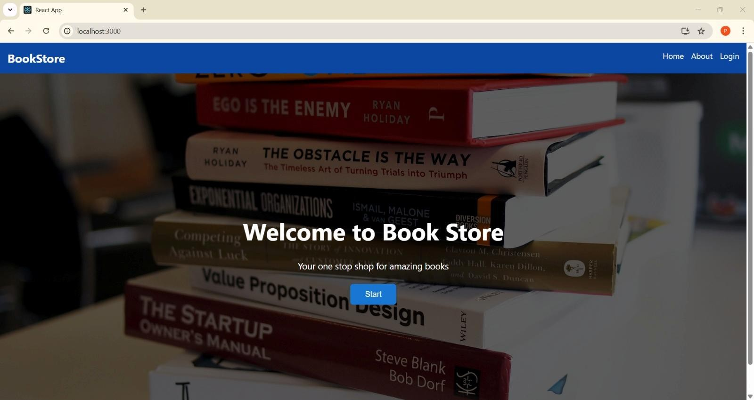

About Page:
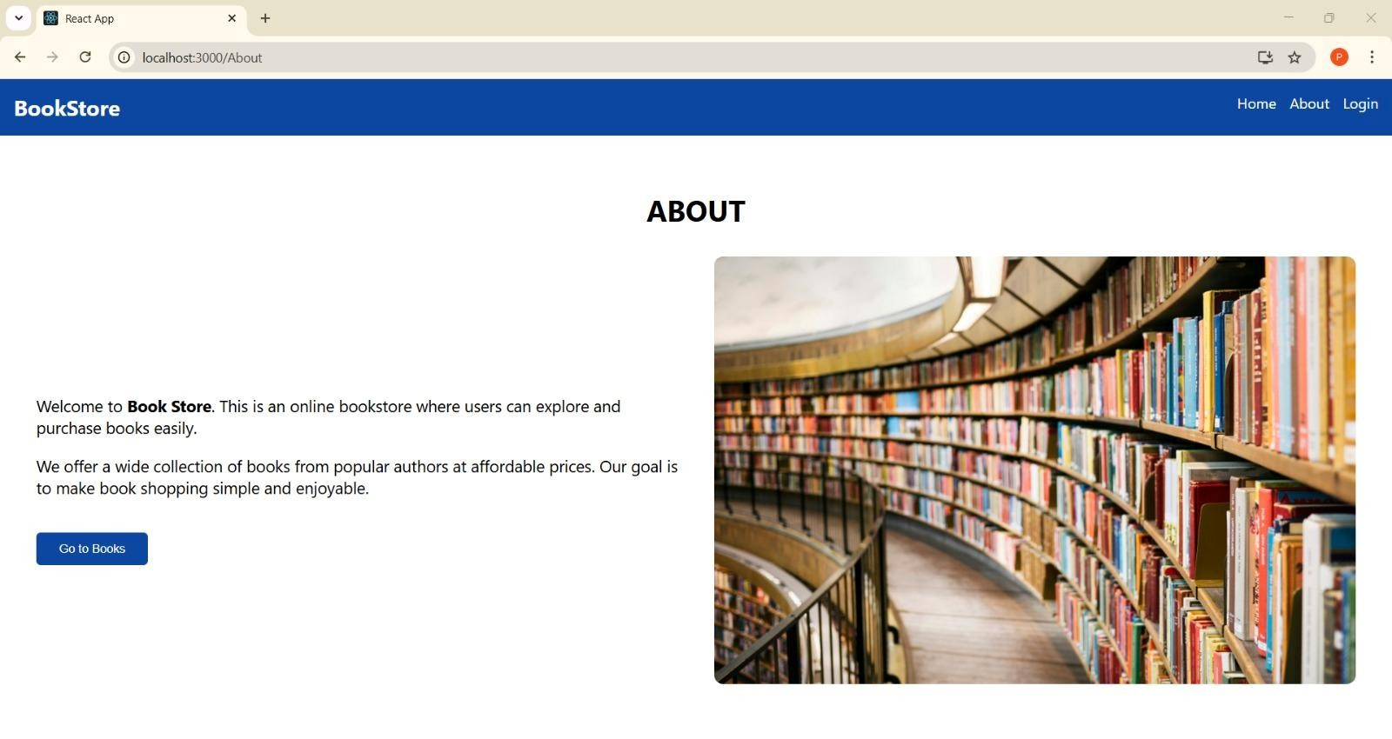
Login Page (Role-based Login)
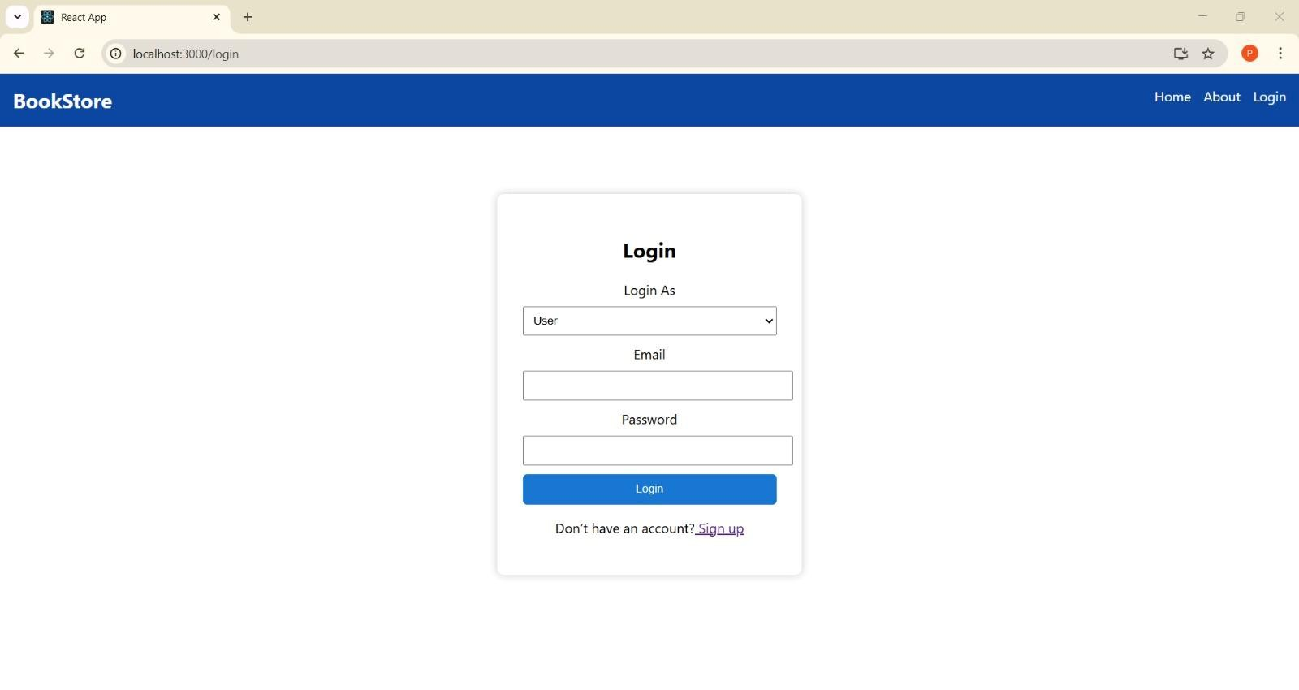

Signup Page (Role-based Registration)
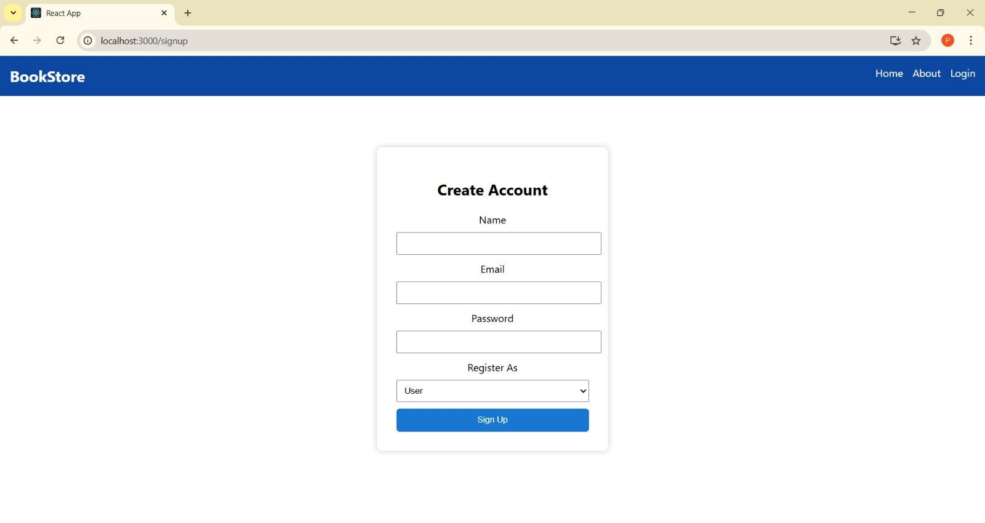

User Dashboard:
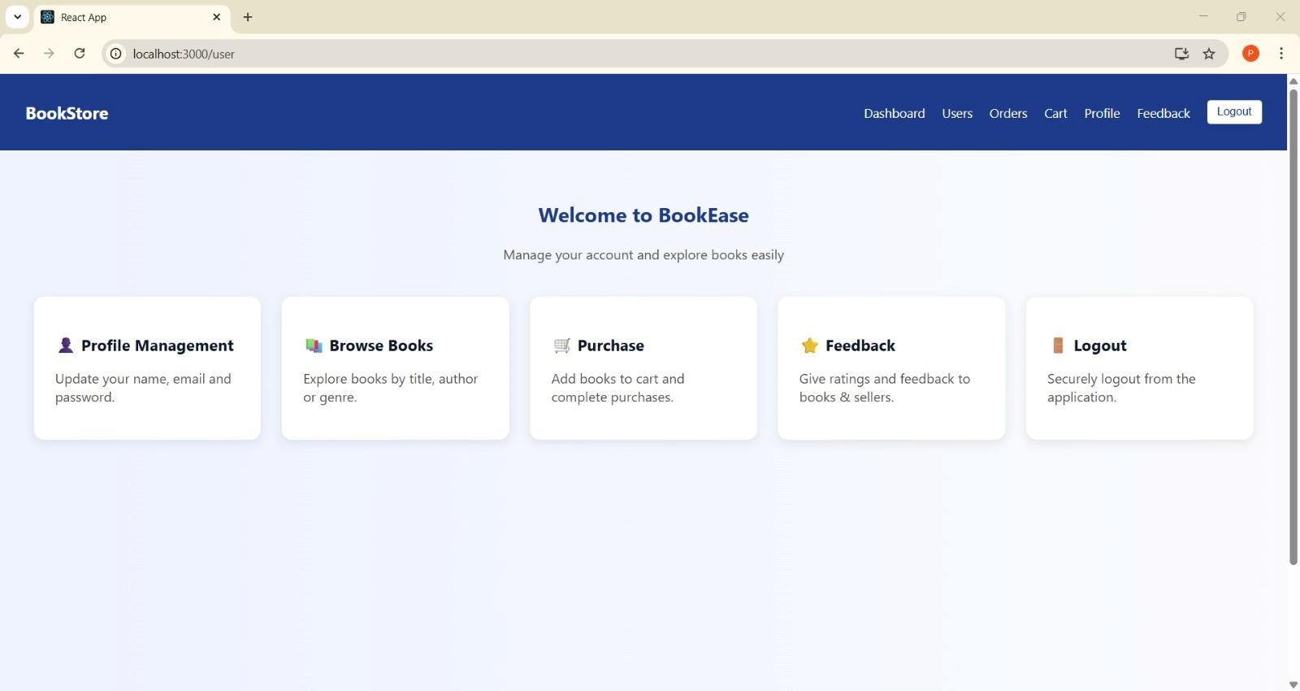

Users Management:
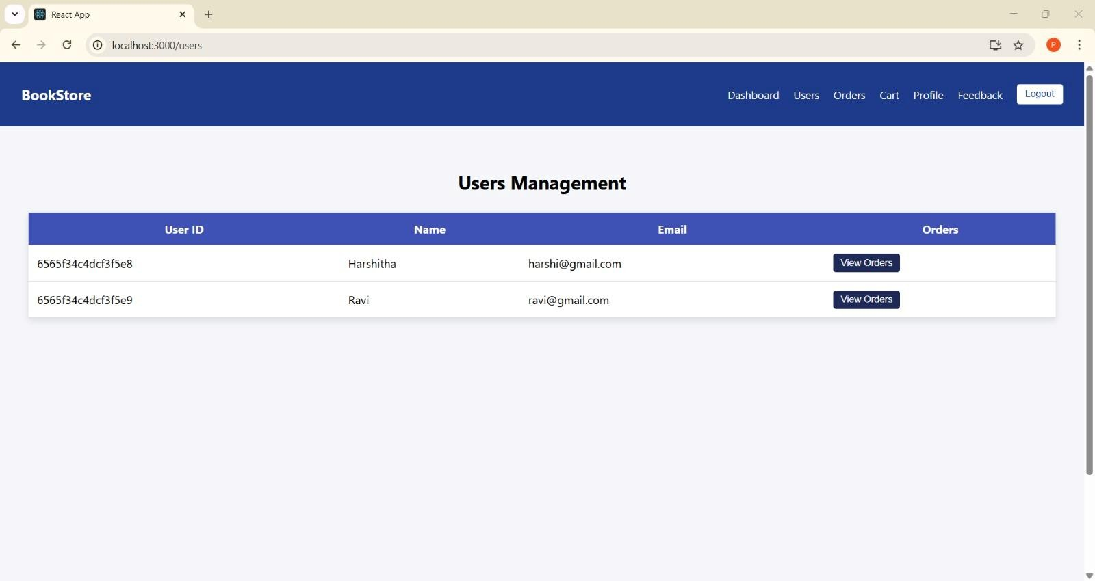

User Orders Page:
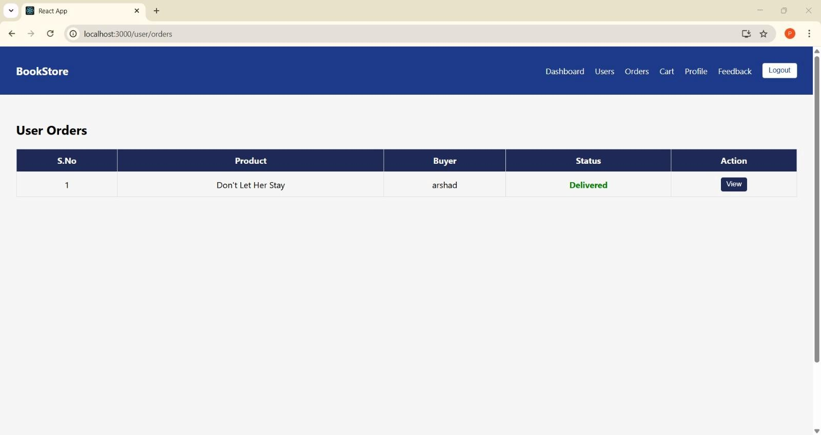
Seller: Dashboard:
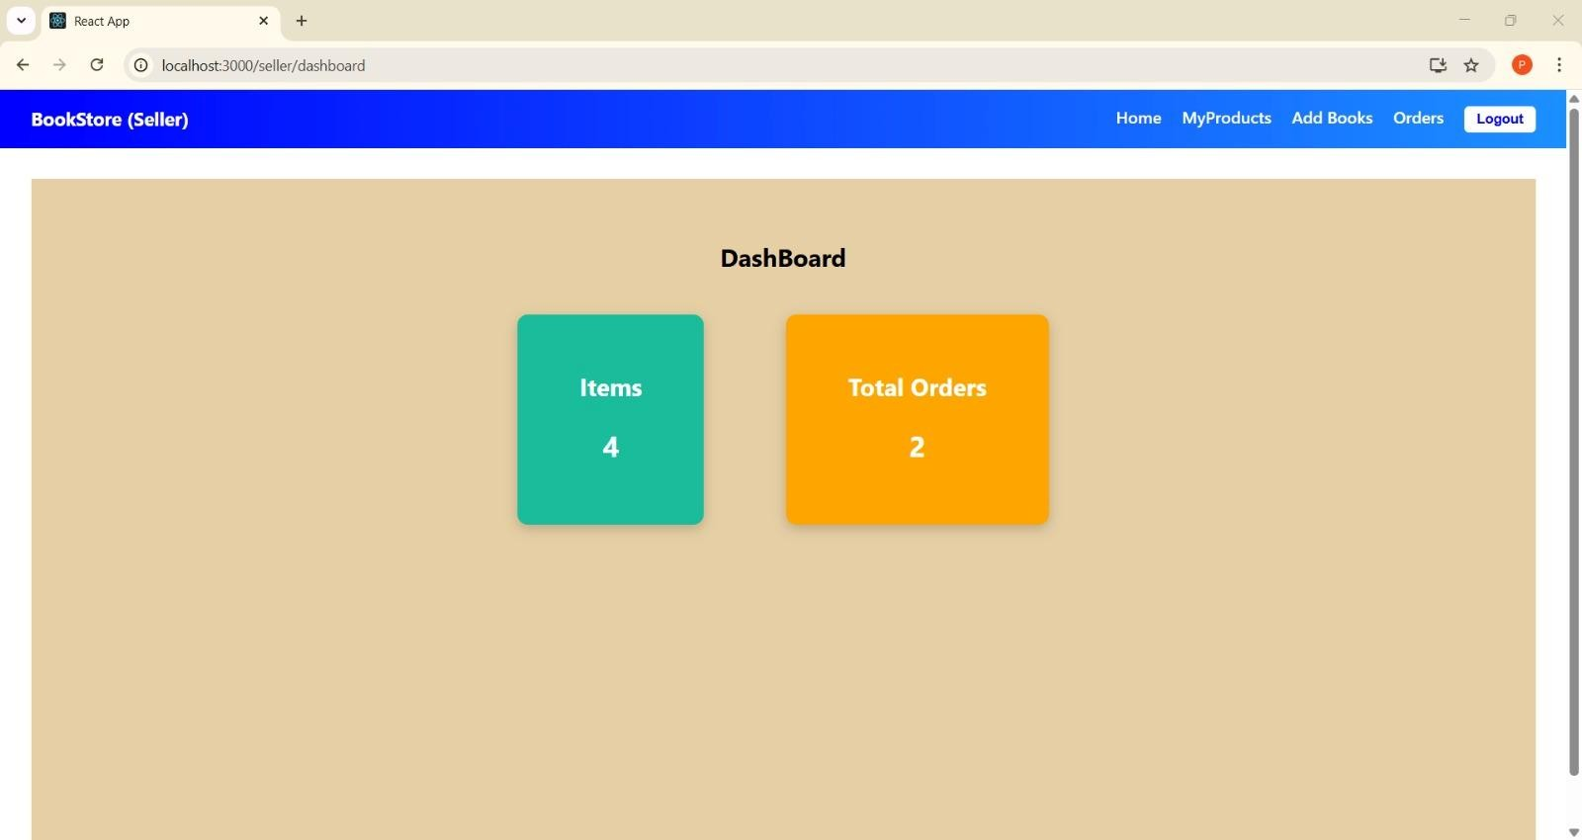

Seller: Vendor Products:
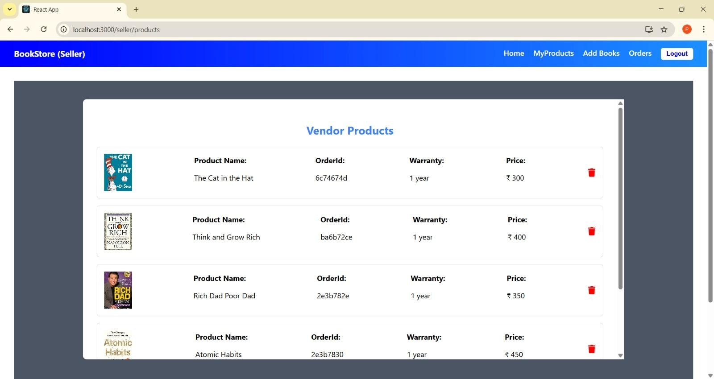
Seller:Add Books:
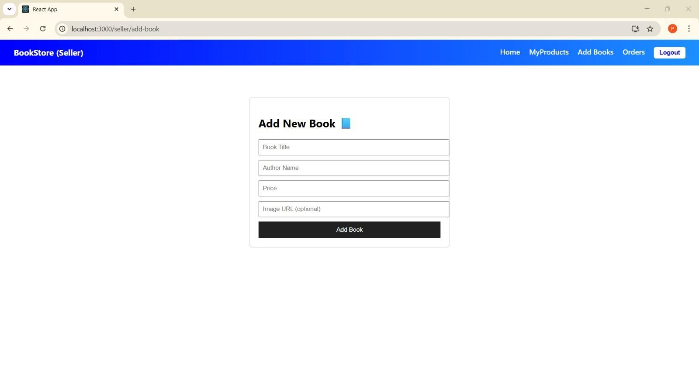

Admin: BookList:
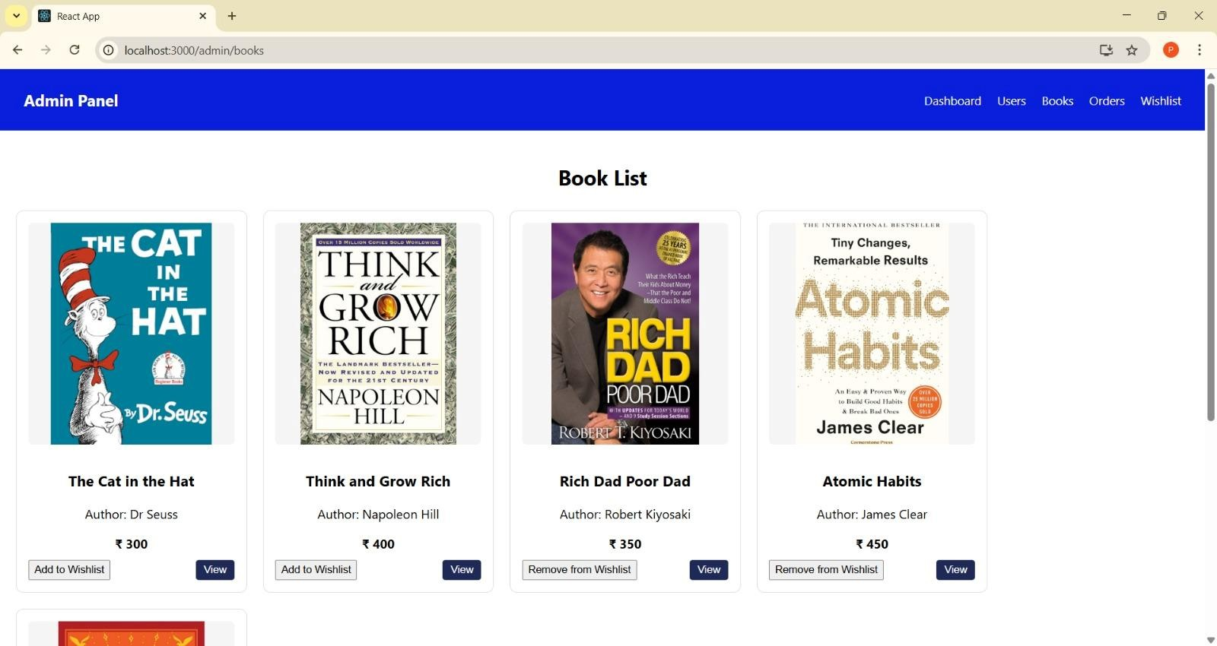
Admin: Wishlist
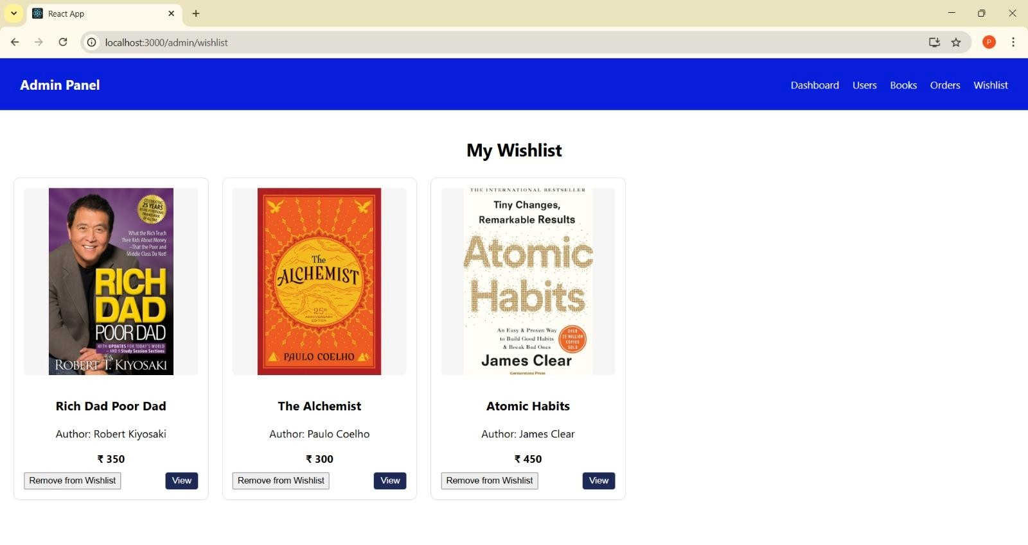

Admin:Orders:
